 RECRUITING ASSISTANCE FOR THE HR

MANAGERS

1. **INTRODUCTION** 
   1. Overview

* This project is used for recruiting the employers for the large company it supports HR team is access the datas.
  1. Purpose
* IT is management software allows HR team effectively to store and access the data efficiently

**2 Problem Definition & Design Thinking** 2.1 Empathy Map 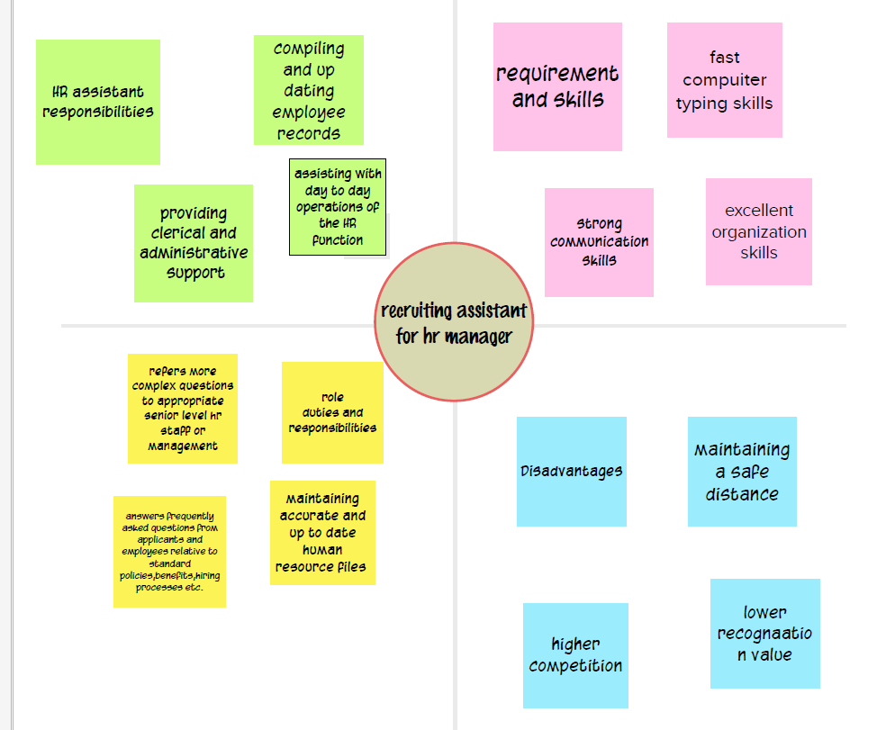

2.2 Ideation & Brainstorming Map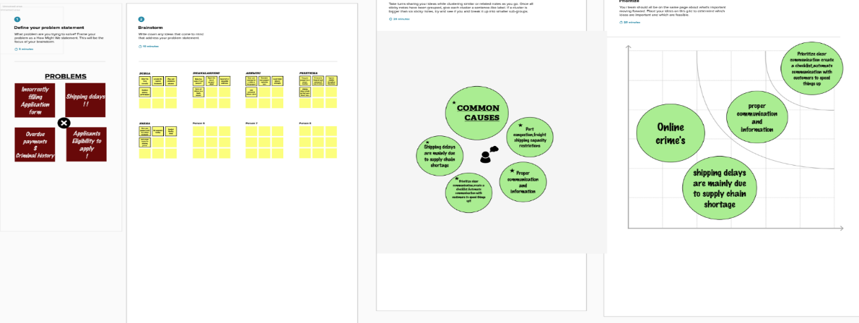

1. **RESULT**

* 1. Data Model:

|  |  |  |
| --- | --- | --- |
|  | Field label | Data type |
| Object 1 | Jobposting | Text |
| Object 2 | Name | Text |
| Object 3 | Contact Number | Numaric |
| Object 4 | Date | DD/MM/YY |

* 1. **Activity & Screenshot** 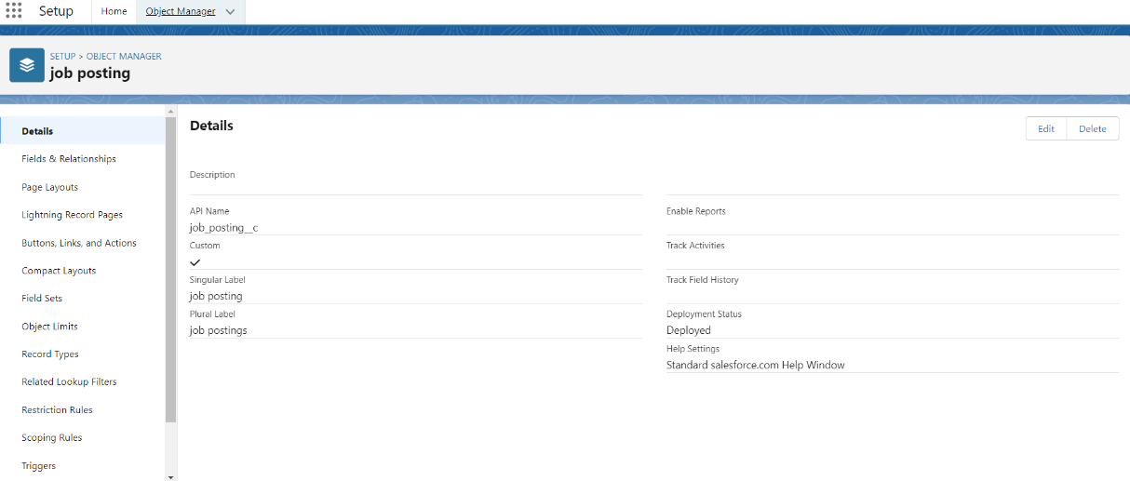

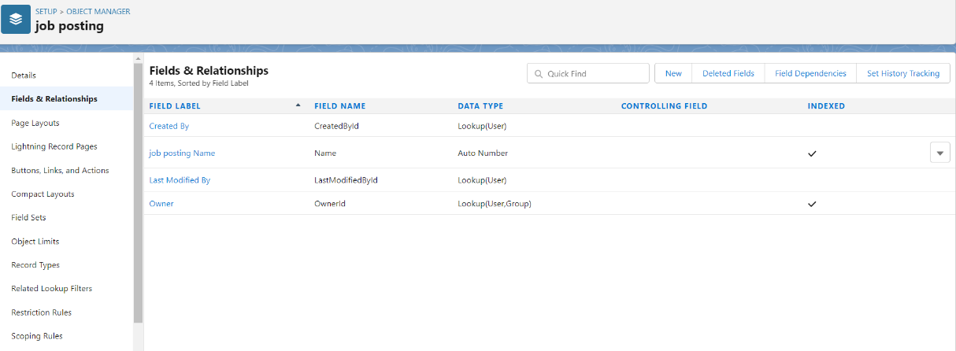the screenshots of your project activity along with the description.

1. **Trailhead Profile Public URL**

**Team Lead -** [**https://trailblazer.me/id/vranjithj**](https://trailblazer.me/id/vranjithj)

**Team Member 1 -** [**https://trailblazer.me/id/velmt**](https://trailblazer.me/id/velmt)

**Team Member 2 -** [**https://trailblazer.me/id/venkat8765**](https://trailblazer.me/id/venkat8765)

**Team Member 3 –** [**https://trailblazer.me/id/sumas61**](https://trailblazer.me/id/sumas61)

1. **ADVANTAGES &**

* It gives higher quality of candidates for the post.

DISADVANTAGE

* Increases the training cost for new applicant.

1. **APPLICATIONS**

* It helps in funding potential candidates
* It is used in application management software.

1. **CONCLUSION**

* HR management software helps in finding ,short listing and interviewing the candidates for company.

1. **FUTURE SCOPE**

* It helps in finding and analysing better candidates for company needs.